CS4600 Homework 5 – Public Key Infrastructure

Task 1: Becoming CA authority

1. Set up directory and files as mentioned

Task 2: Create a Certificate for SEEDPKLab2020.com

1. Generate self-signed certificate for CA. PEM passphrase - Ucla

1. Generate keys

1. Generate certificate signing request

1. Generate certificate

Task 3: Deploy Certificate in HTTPS Web Server

1. Configure DNS through vi/etc/host

1. Combine secret key and certificate into permission file

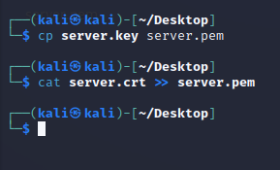

1. Configure browser to accept CA certificate

1. When 1 bit is changed in server.pem, website can’t launch

1. Connection to <https://localhost:4433> leads to the same website

Note: this is done on a Kali VM and may not have the “secured” padlock if it was done on the same SeedLab VM specifically configured.

Task 4: Deploying Certificate in an Apache-based HTTPS Website

1. First, copy server certificate and key and move it to /etc/apache2/ssl

1. Add the following section to /etc/apache2/default-ssl.conf

1. Configure html file for “Hello World” and successful browse below

